Auto Ticket Classification using Flow Designer
Part 3 of 7 — Field Creation & Data Type ConfigurationPart 3 of 7 — Field Creation & Data Type Configuration

Activity 2: Field Creation and Data Type Configuration
The objective of this milestone is to create all required fields in the School IT Ticket table with correct data types, choices, and dependencies, ensuring structured and consistent data capture.
Field Label | Type | Reference/Choice
Number | Auto Number | —
Caller | Reference | sys_user
Category | Choice | Network, Hardware, Access, Performance
Subcategory | Choice | Wi-Fi, Projector, Forgot Password, Slow Computer
Short Description | String | –
Description | String | –
State | Choice | New, In progress, On hold, Resolved, Closed
Assigned Group | Reference | sys_user_group
Assigned to | Reference | sys_user

- After creating fields with their appropriate type, add the Choice from the Form Design.
- Apply this to all Choice list fields: Category, Subcategory and State.
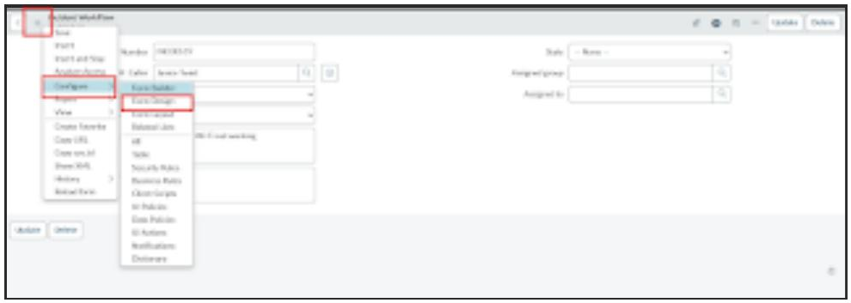
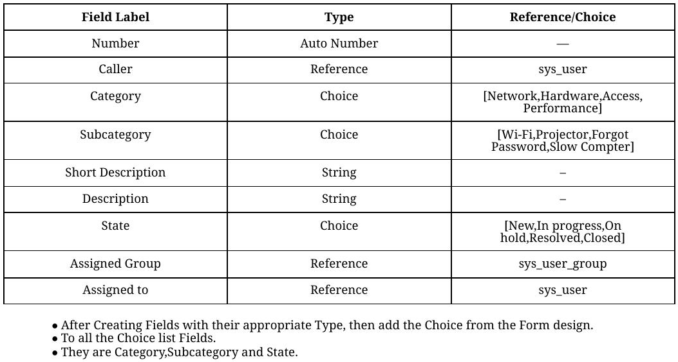
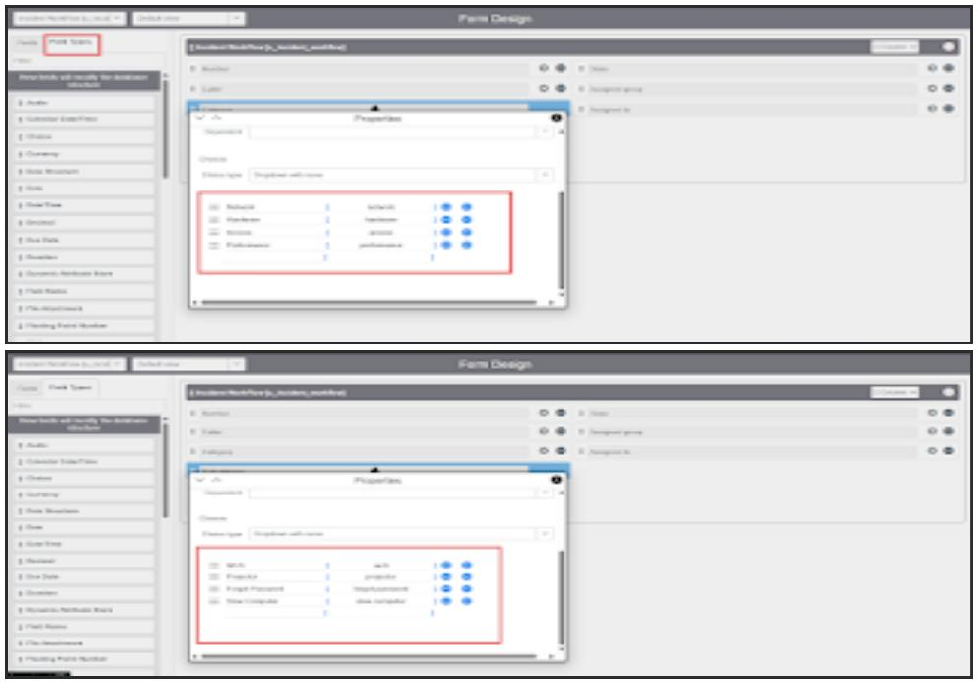
- Add Choice values the same way to the State field.
- Then click the Save button on the top right corner.
- Open the Form and reload it.

